Port of Milford Haven Stakeholder perception survey 2018
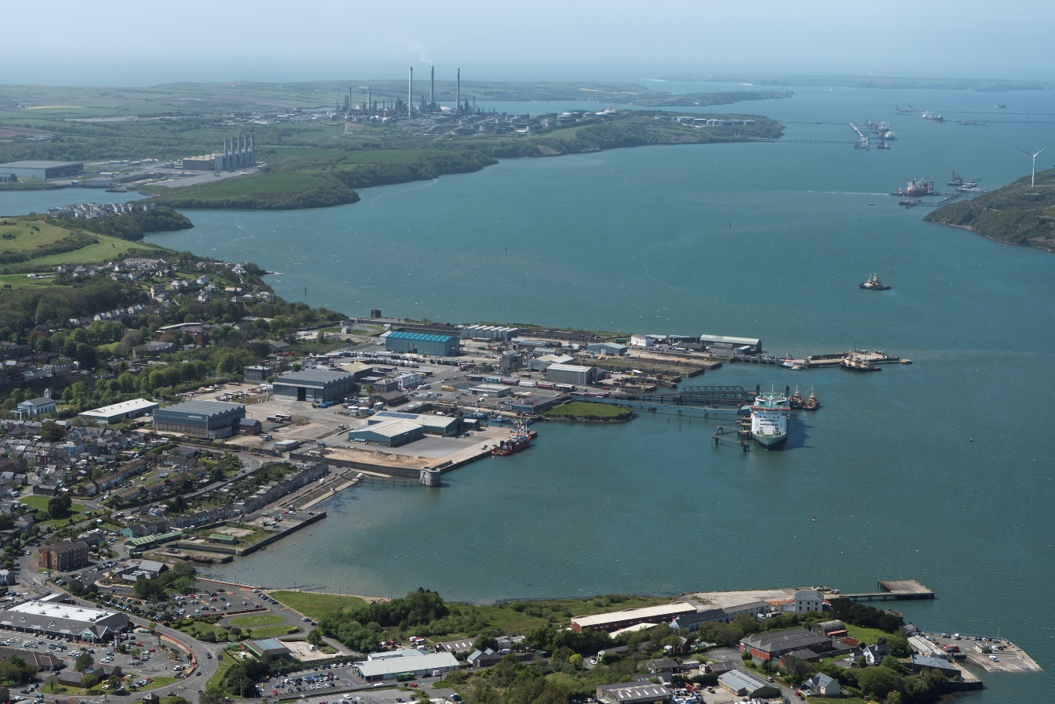

Report by:
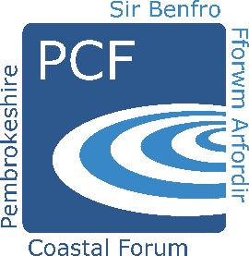
Pembrokeshire Coastal Forum,
2nd Floor, Pier House, Pembroke Dock, Pembrokeshire, SA72 6TR
www.pembrokeshirecoastalforum.org.uk

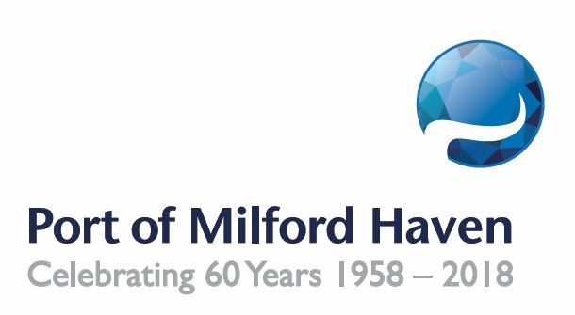

Report prepared for:
Port of Milford Haven
Manager: | Anna Malloy
Address: | Port of Milford Haven,  Gorsewood Drive,  Milford Haven,  Pembrokeshire,  SA73 3ER
Telephone: | 01646 696156
Contract reference | POMH/2018

Report prepared by:
Pembrokeshire Coastal Forum CIC
Project Manager: | Holly Pretious
Address: | Pembrokeshire Coastal Forum CiC,  2nd Floor, Pier House,  Pier Road  Pembroke Dock  Pembrokeshire  SA72 6TR
Telephone: | 01646 405690

Report Warranty
This report has been prepared with due care and diligence and with the skill reasonably expected of a reputable contractor experienced in the types of work carried out under the contract and as such the findings in this report are based on an interpretation of data which is a matter of opinion on which professionals may differ and unless clearly stated is not a recommendation of any course of action. PCF have prepared this report for the client identified on the front cover in fulfilment of its contractual obligations under the referenced contract and the only liabilities PCF accept are those contained therein. Please be aware that further distribution of this report, in whole or part, or the use of the data for a purpose not expressly stated within the contractual work scope is at the client’s sole risk and PCF recommends that this disclaimer be included in any such distribution.

Executive Summary

This stakeholder perception survey is the fifth survey conducted by the Pembrokeshire Coastal Forum (PCF) for the Port of Milford Haven (POMH) and aims to build upon the findings from the reports written in 2009, 2014, 2016 and 2017. This survey was a replica of the one used in 2017 with a few minor edits so that direct comparisons could be made. The survey was marketed to a broad range of stakeholders from local community members, business owners, Port customers, suppliers and statutory bodies. In total 430 people took part.
Overall the results of this survey give a positive view of the Port of Milford Haven, the majority of respondents agreed that the Port should be undertaking a range of different activities, particularly that they should be investing in a way that creates new economic opportunities and attracting new trade and investment. There was an 8% increase in those who agreed with the Port’s role in developing marine renewable energy compared to 2017.
The role of the Port within the local community continues to be of vital importance with 95% of respondents in agreement that the Port should continue its community work and 86% of people feel it is important that the Port should continue to be a Trust Port.
Survey respondents are passionate about the work of the Port and suggestions for other activities that the Port could get involved in are as varied and diverse as in previous years. This year there were several suggestions about how the Port could tackle issues such as marine litter, marine plastics and ghost fishing, perhaps reflecting current key issues in the media.
When asked how the Port was performing against their overall expectations 45% of respondents responded positively, which is an 8% decrease from last year.

Contents

Executive Summary 3
1. Introduction 5
2. Methodology 6
3. Survey Results 7
3.1 Respondent Background 7
3.2 The Work of the Port 9
3.3 The Port and the Community 10
3.4 The Port’s Priorities and Performance 11
3.5 Communication 17
4. Conclusion 18
5. Appendices 19

Introduction

2018 marks the 5th stakeholder survey Pembrokeshire Coastal Forum (PCF) has carried out for the Port of Milford Haven. As a Trust Port, POMH regularly seeks the views and concerns of its stakeholders through its Advisory Board, its Annual Consultative Meeting, its Stakeholder Accountability Committee and various one to one meetings throughout the annual calendar. These views are taken into consideration when planning future strategies and in decision making.
In 2017 the survey was completed by 372 people and the results found that the majority agreed that the Port should be undertaking a range of different activities, particularly supporting local businesses and attracting new trade and investment. 97% agreed that the Port should continue its work in supporting the local community and overall respondents ranked the Port’s performance in key work areas favourably. There was an increase of those that said the Port was meeting or exceeding their expectations compared to 2016.
The aim of this 2018 survey is to measure whether the positivity reflected in 2017 have continued and the questions were designed to gather opinions on matters such as how the Port operates, how it is performing in its duties, and what, in the opinion of its stakeholders, it should be prioritising. This is of particular importance to the Port in 2018 as it undertakes new and significant projects such as Pembroke Dock Marine and the redevelopment of Milford Waterfront. This report will outline the results of the survey and will draw comparisons to 2017 throughout.

Methodology

PCF were asked by the Port of Milford Haven to promote, analyse and report on this 2018 survey. The Port provided the survey questions and a list of defined stakeholder categories. PCF were asked to use their contacts and networks to identify a list of individuals to contact within each category, many of whom completed the survey in 2017. The Port also provided a contact list of individuals to contact. Those targeted included local residents, local business owners, Town & Community Councillors, schools, government officials, Port customers and suppliers, among others. The survey questions can be seen in Appendix A.
The survey was created online using www.surveymonkey.com and individuals identified within the stakeholder categories were contacted via email or phone and asked to complete the survey. The link to the online survey was also posted on PCF’s social media (Facebook, Twitter and LinkedIn), on the PCF website and in the PCF e-newsletter. The Port of Milford Haven also produced several social media posts themselves promoting the survey. The survey was emailed to several of PCF databases: PCF members and Pembrokeshire Outdoor Charter members. £100 worth of vouchers to be spent at a Milford Waterfront retailer, restaurant or café were offered as an incentive. The survey was open between 1st to 30th June 2018 and during this time it was completed by 430 people.
The survey results were then analysed and for the purposes of this report have been broken down into the following sections:
- Respondent Background
- The Work of the Port
- The Port and the Community
- The Port’s Priorities and Performance
- Performance Measurement
- Communication
These sections are the same as used in the 2017 report in order to allow a direct comparison.
All figures in this report have been rounded to the nearest whole number. The full datasets can be found in Appendix B.

Survey Results

Respondent Background

This year’s survey drew responses from people in a range of geographical locations came from a variety of locations across Pembrokeshire and beyond. Of the 30% of people that lived in an ‘other’ location, the majority came from other parts of Pembrokeshire e.g. Crymych, Maenclochog, Fishguard, Narberth, Saundersfoot, Solva or Tenby, and others came from other parts of Wales such as Carmarthen, Swansea, Cardiff and Anglesey. 12 came from outside of Wales, including one person from France.
37% of people defined themselves as a local resident, which is a 20% reduction compared to 2017. 16% were recreational users of the Haven Waterway and 8% were county, town or community councillors. Those that defined themselves as ‘other’ gave a variety of descriptions including:
- Annual Berth Holder - Milford Marina
- Coastguard
- Environmental Charity Policy Manager
- Former Crown Managing Agent
- Founder of Local Heritage Conservation Trust
- Landlord of property in Pembroke dock
- Leader, Pembrokeshire County Council
- Mid and West Wales Fire and Rescue Service
- Previous Chairman of the Milford Haven Users Association
- Resident and Member of the local Pembroke Dock Town Team
- Second home owner

Q2.1 was only available to those who identified themselves as customers or suppliers of the Port (7.4% of the total respondents). In 2017 100% of respondents rated the Port’s service as ‘very good’, ‘good’ or ‘average’ and in 2018 this has dropped slightly to 84%.

The Work of the Port

3.1 Invest profits to develop Pembroke Port as an internationally recognised centre for the development, build, test and launch of marine renewable technology
3.2 Invest profits to develop Milford Waterfront as a vibrant, year-round retail and leisure destination
3.3 Invest in a way that creates new economic opportunities
3.4 Act as a regional champion to help attract new trade and investment to Pembrokeshire
3.5 Invest in the development of the commercial fishing and aquaculture industry around Pembrokeshire

When looking at the activities which people most agree with, marine renewable energy has received an increase of 8% compared to 2017, the most significant change. Over 50% of respondents strongly agreed with all 5 activities.
79% of local councillors/politicians agree that the Port should be investing in marine renewable energy compared to 87% of local residents and 87% recreation users of the Haven. Conversely, 88% of local councillors/politicians agree that the Port should invest in the commercial fishing and aquaculture industries compared to 81% of local residents and 64% of recreational users.
Overall all five activities were viewed favourably. 15% of respondents were ‘neutral’ towards the development of the fishing and aquaculture industries, and 10% disagreed (either strongly or slightly) with the development of Milford Waterfront.

The Port and the Community

For Q4, respondents were provided with a description of what it means to be a Trust Port, the benefits this provides and the ways in which the Port is able to support local businesses and communities.
Q4.1 shows very little change from the results obtained in 2017 with 95% of people thinking it is important that the Port supports local community-based organisations (96% in 2017).

86% think that it was important for the Port to remain a Trust Port (4% less than in 2017).
Q5 asked respondents if they were aware of any community projects that have been supported by the Port, to which 65% replied yes. This is a 7% reduction compared to 2017.

The Port’s Priorities and Performance

Q6 asked respondents to place 10 of the Port’s activities in order of priority, according to their views. To analyse the data, each time an activity was ranked 1st it was awarded 10 points, 9 points for 2nd, 8 for 3rd etc. The list below is the ranked order of priorities when an average was taken for these scores (the average score is shown in brackets.
- Ensure the safe movement of vessels on the Milford Haven Waterway (8.76)
- Prevent pollution (7.80)
- Support existing Pembrokeshire-based businesses (6.01)
- Manage recreation on the Milford Haven Waterway (5.85)
- Attract new trade and investment to Pembrokeshire (5.77)
- Invest profits to promote the marine renewables industry in Pembrokeshire (5.01)
- Support the commercial fishing industry around Pembrokeshire (4.95)
- Invest profits to make Milford Waterfront a leading retail and leisure destination (4.04)
- Support the Pembrokeshire community and community-based organisations (4.01)
- Attract a new aquaculture sector to Pembrokeshire (2.63)

When comparing these results to last year’s survey, the same activities appear as the top 5 priorities and the top 3 are exactly the same.
‘Manage recreation’ and ‘attract new trade and investment’ have swapped places, as have supporting the marine renewables industry and the commercial fishing industry. Supporting Pembrokeshire communities has climbed a position whilst ‘attract a new aquaculture sector’ is a new category for 2018 and has ranked 10th.
The graph on the following page breaks down these results to show five activities where there are noticeable differences between key stakeholder groups. Visitors to the area prioritised recreation management and community support higher than any other stakeholder group, whereas local residents favoured the development of Milford Waterfront. Marine renewable energy was popular among local politicians and councillors, as well as water-based business owners.

NB. The higher the score, the more often the activity was ranked as high priority

Q7 respondents were asked for suggestions of other activities that the Port should get involved with which would make a positive contribution to the Pembrokeshire economy. This question received a wide range of different answers, below are some of the key responses categorised and paraphrased, the full list can be found in Appendix C.
Businesses
- Lead a strong business forum which can make representation that can have effect
- Loans/grants/joint ventures to support new business start-ups to fill supply chain gaps or add tourism attractions
- Support local marine businesses more on the haven to ensure a fair and collaborative approach to promote water leisure

Community
- More events that local charities could attend to drum up support and funding
- Support town and community councils and town teams/ community forums to host events and activities to get communities together.
- PAVS would love to see a Pembrokeshire-wide Community Fund developed with exploration with some of the key players like the Port Authority to find a workable model. PLANED is currently running a scoping exercise to look at this but, from prior work carried out by PAVS into the feasibility, it is likely that amounts of funding required to secure adequate longer terms returns might be prohibitive. In the past PAVS and the Port of Milford Haven have worked jointly to deliver Treats for Time and the Port also invested in the GrantNET service. There could be other future opportunities along a similar vein of partnership which would be worth exploring.

Education &Employment
- Engage with all Pembrokeshire schools
- Training in boat skills/handling/navigation etc.
- Technical College e.g. MITEC develop marine careers opportunity for local youth
- Marine and Coastal Education / training opportunities to retain local people in the county
- Training and education for young people, focussed on marine sector - marine engineering, boat design/building, etc.
- Support and encourage all local primary schools, to explain all the varied employment opportunities both within the port authority areas, and also those to be found within the surrounding land-based businesses.
- Invest in Schools projects to develop the young people of Pembrokeshire for a career within the port and in marine renewables
- Local kids learning water sports and water safety
- Internships for school leavers and grads and sponsoring schoolchildren interested in local engineering initiatives

Energy & Environment
- Develop innovative ways to address plastic marine pollution and become a disposable plastic free zone
- Support the removal of ghost fishing gear, marine litter, etc to promote environmental tourism
- Promoting the enforcement of marine conservation zones around the Pembrokeshire Coast, and developing further sustainable ecotourism as a result
- Actively support Pembrokeshire Coast National Park priorities; Stop ships from anchoring as close to shore near the Pembrokeshire Coast National Park while they wait to enter Milford Haven. This is bad for marine resources and for tourism.
- Marine energy
- Things which enhance the natural resources of the area, bringing Milford Haven in line with much of Pembrokeshire as a destination for wildlife and landscape tourists.
- Community Energy Pembrokeshire / Other renewable energy activities
- Any sustainable renewable energy generation which can provide a gateway for long term employment in the region. Look at how the Irish ports have worked together with education and industry - learn lessons - so that MHPA is viewed as the catalyst.

Fishing
- Recreational Angling
- Lobster hatchery, Invest in alternative fish farming activities like sea urchins
- Cooperate with RYA and MCA on campaigns to improve marking of fishing pots thus making it safer for recreational boating. Provide a local shellfish/fish retail facility to enable inshore (local) fishermen to sell their catch directly to the public

Heritage
- Pembroke Dock heritage centre
- The promotion and protection of the local marine associated built heritage.
- Upgrade and develop Pembroke Dock to emphasise the history and heritage of the town as a visitor attraction. Change the name of Pembroke Port to Port of Pembroke Dock.
- Supporting the maritime museum, Milford and the h/west museum
- Heritage Tourism

Infrastructure/development
- Ensure the long-term viability of Milford Haven’s dry dock infrastructure.
- Development of a barrage at Pennar gut in order to provide a safe enclosed area for water borne youth activities near power station
- Improve deep water quay space with in the Milford Haven waterway. Work with other to improve rail and road infrastructure in an integrated strategy
- Improving slipways and water access in local communities. Not just on their own sites for charge, there are limited safe slips in good condition.
- Transform the derelict forts around the waterway into hotels/spas, Aquarium, tourist attractions.

Leisure
- Fishing/Angling groups
- Outdoor pursuits - coasteering/kayaking
- Fun run
- Torch Theatre / A programme for raising the aspirations of young people / An arts/literature/cultural festival which creates/develops Pembrokeshire’s identity and national presence
- Bringing horse racing back to Haverfordwest, enabling local trainers to race in Pembrokeshire rather than in England
- Pembrokeshire Ladies Cricket, Llangwm rugby club, Milford Haven golf junior section, St Ishmaels Sports and Social club
- Promote subsea diving in Pembrokeshire and improve launch facilities for water users
- Development of recreational aspects of the waterway - especially for divers. Create a reef (Dale roads) as a nursery area for crustaceans and to attract divers - sink a ship there, tie tyres together with steel rope concrete lumps... would make it a locus for diving ...
- Volvo Ocean Race Stopover. More sail racing generally. More water sports events.

Tourism
- Using Milford and Pembroke as ports you can go on cruises from, rather than just cruise ships visiting the ports. Otherwise you have to travel to Southampton or Tilbury which takes you most of the day to get to.
- Develop a world class Aquarium in Milford Haven.
- Larger National Activities that bring visitors to the area...e.g. Cliff diving (Abereiddy) Ironman, Tough Mudder, Car/Boat/Motorcycle Events.
- Improving upriver tourism and business opportunities by championing water access connections for communities along the waterway.
- Boat trips in the haven and up the Cleddau

In addition to these suggestions, a number of positive comments were made about the Port’s activities including:
- I think you do a great job already, but maybe should publicise that more.
- The Port of Milford already does a fantastic job in Pembrokeshire and should be proud of its record.
- The Port is incredibly active in supporting Pembrokeshire communities - carry on the good work!
- No strong views, best decided by the port's board taking account of its statutory responsibilities, commercial needs and views of local stakeholders
8.1 Ensuring the safe movement of vessels on the Milford Haven Waterway
8.2 Managing recreation on the Milford Haven Waterway
8.3 Preventing pollution
8.4 Supporting existing Pembrokeshire-based businesses
8.5 Attracting new trade and investment to Pembrokeshire
8.6 Supporting the commercial fishing industry around Pembrokeshire
8.7 Promoting the marine renewables industry in Pembrokeshire
8.8 Developing Milford Waterfront as a leading retail and leisure destination
8.9 Supporting the community and community based organisations
Q8 asked respondents to rate the Port’s performance in a number of key areas and when comparing to 2017’s results (see previous page) it has produced remarkably similar results. Overall every activity had a postive rating from the majority of respondents, with the highest rating for “ensuring the safe movement of vessels (89% said this was very good, good or average) and the lowest rating for “supporting the commercial fishing industry” with 57% rating this very good, good or average. The number of people not sure about the port’s performance has increased for every activity since 2017.
When asked how the Port was performing against their overall expectations (Q9) 85% of respondents ranked the Port as a 3, 4 or a 5 (Neutral, Well, Very Well), which is a 3% increase from last year and 17% increase over 2 years. Overall, visitors and water-based business owners were the most satisfied as 100% ranked the Port as a 3, 4 or 5. Local politicians/councillors and recreation users were also very satisfied with 90% and 85% respectively ranking the Port as a 3, 4 or 5. Several stakeholder groups have seen an increase in overall satisfaction including local residents (5% increase), land-based business owners (3%) and recreation users (2%). Port customers and port suppliers have had a drop in satisfaction by 19% and 21% respectively.

When asked how the Port was performing against their overall expectations 45% of respondents responded positively (well or very well), 15% responded negatively (some improvement needed or much improvement needed), and 40% gave a neutral response. Excluding those that expressed a neutral response, 75% expressed satisfaction with the Port’s performance, compared to 25% that expressed dissatisfaction with the Port’s performance.

When asked in Q10 if they had any concerns regarding the Port’s activities, 70% said no – a 2% increase from 2017.

Communication

Q11 gave respondents a description of the OnBoard publication and asked how it had impacted their awareness and understanding of the Port. 48% responded positively, which is a 1% increase compared to 2017. The number of people that had never seen OnBoard has dropped by 1% since last year.

Q12 asked respondents which form of communication they find most useful for keeping up to date with Port news and developments. Over the last two years the results have fluctuated massively. 2017 saw Facebook as a clear favourite but its popularity has reduced in 2018. Email was the most popular in 2016 and is again in 2018. OnBoard has seen a continuous rise over the last two years.

Conclusion

This survey has given a positive overall view of the Port and its activities, which is comparable to the results from last year. Below is a summary of the results:
- A large majority of people undertaking this survey were local residents and 70% lived within one of the major towns on the Haven Waterway, demonstrating the strong links between the Port and the town. There were also people participating in the survey from all over Pembrokeshire and further afield including outside of Wales (and even outside of the UK) which reflects the Port’s far-reaching influence. This survey received respondents from a broader range of stakeholders than previous surveys.

- Customers and suppliers rated the service they receive from the Port favourably.

- The majority of respondents agreed that the Port should be undertaking a range of different activities, particularly that they should be investing in a way that creates new economic opportunities and attracting new trade and investment.

- There was an 8% increase in those who agreed with the Port’s role in marine renewable energy compared to 2017.

- The Port has consistently supported the community through a broad range of initiatives including sports clubs, community groups and local societies, as well as organising and sponsoring events. 95% of survey respondents agree that the Port should continue its community work. 86% think it is important for the Port to remain a Trust Port.

- Many suggestions were provided regarding other activities the Port should get involved in, many of which have been suggested every year this survey was conducted - such as more events and more work with schools. This year there were many more suggestions about how the Port could tackle issues such as marine litter, marine plastics and ghost fishing, perhaps reflecting key issues of today.

- The Port’s performance was generally seen favourably; with the same two activities which were thought to be the main priorities also being seen as the ones which the Port was performing well in (safe navigation of shipping and pollution prevention). There has been very little change in perception of Port performance between results from 2017 and from 2018 as every activity had a positive rating from the majority of respondents.

- When asked how the Port was performing against their overall expectations 45% of respondents responded positively, which is an 8% decrease from last year.

- The OnBoard publication has seen a continuous rise in popularity but email is the preferred method of communication for the majority of people, which is a change from 2017 where Facebook was the most popular.

- There has been a 15.6% increase in the amount of people taking part in this survey since 2017, and a 70% increase since 2016.

Appendices

Appendix A
Survey Questions for 2018 survey
Appendix B
Raw Data from 2018 survey
Appendix C
Full set of answers for Question 7 - What other activities do you think the Port of Milford Haven should get involved with?

