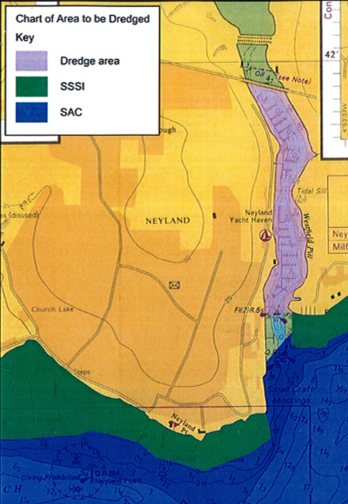

**Dredge pipe marker buoy**