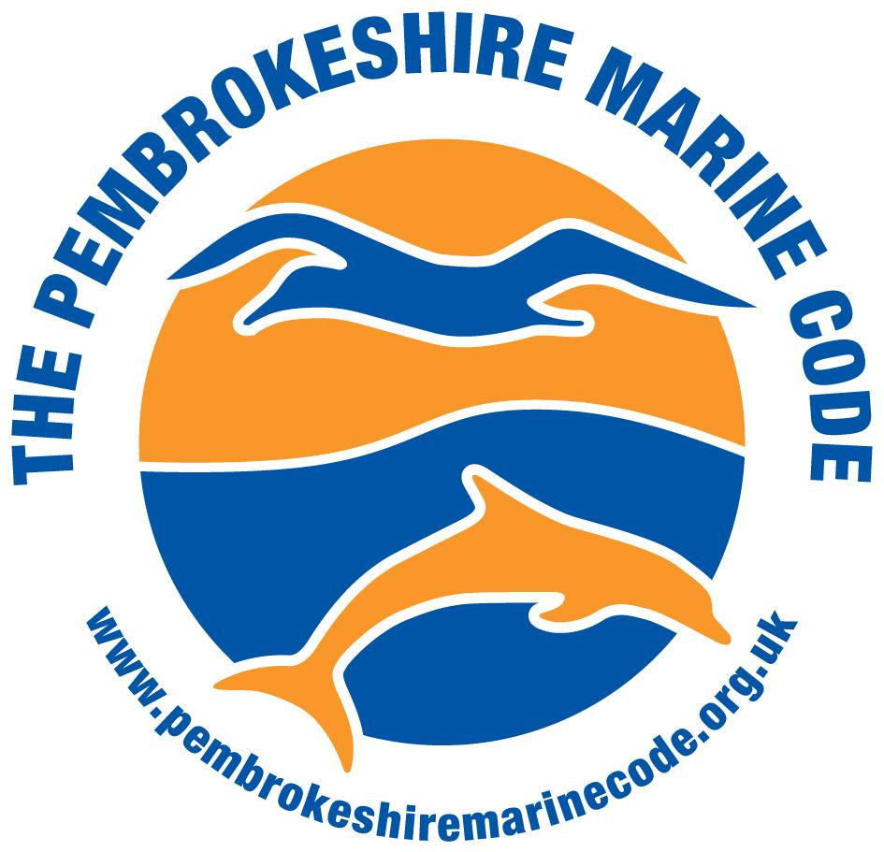
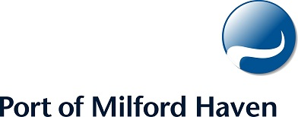

Guidance Notes for Event Organisers

March 2024

Produced by the Port of Milford Haven in collaboration with the Pembrokeshire Marine Code Group.
Background

Pembrokeshire has a spectacular coastline and is internationally important for wildlife. Much of the coastline and offshore areas of Pembrokeshire are designated and protected for nature conservation. Milford Haven Waterway has seen developments making it the biggest port in Wales and the energy capital of the UK. All this is in the heart of the Pembrokeshire Coast National Park, the only Coastal National Park in Great Britain.

Due to the high levels of commercial traffic to and from the port, the importance of Pembrokeshire for wildlife, the popularity of the Waterway and Pembrokeshire for recreational vessels, it is essential that any events planned in the marine environment within port limits seek the permission of the Port of Milford Haven and involve all relevant stakeholders and conservationists at an early stage of planning.

The Port of Milford Haven is responsible for the area within the blue boundary as marked on the map below. This is a busy shipping area - during 2023, the Port handled 38.9 million tonnes of cargo. The Port of Milford Haven are also strong supporters of the Pembrokeshire Marine Code and require all event organisers and participants to follow the Pembrokeshire Marine Code within this area.

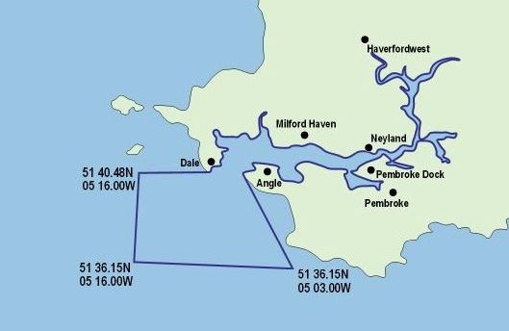
Figure 1 Port of Milford Haven Port limits

The Pembrokeshire Marine Special Area of Conservation (SAC) encompasses 138,069.45ha of Pembrokeshire’s coastal waters, which includes the entire waterway and most of the majority of the seaward port limits as shown below. It is strongly recommended by the SAC management team that all users follow the Pembrokeshire Marine Code to safeguard wildlife.

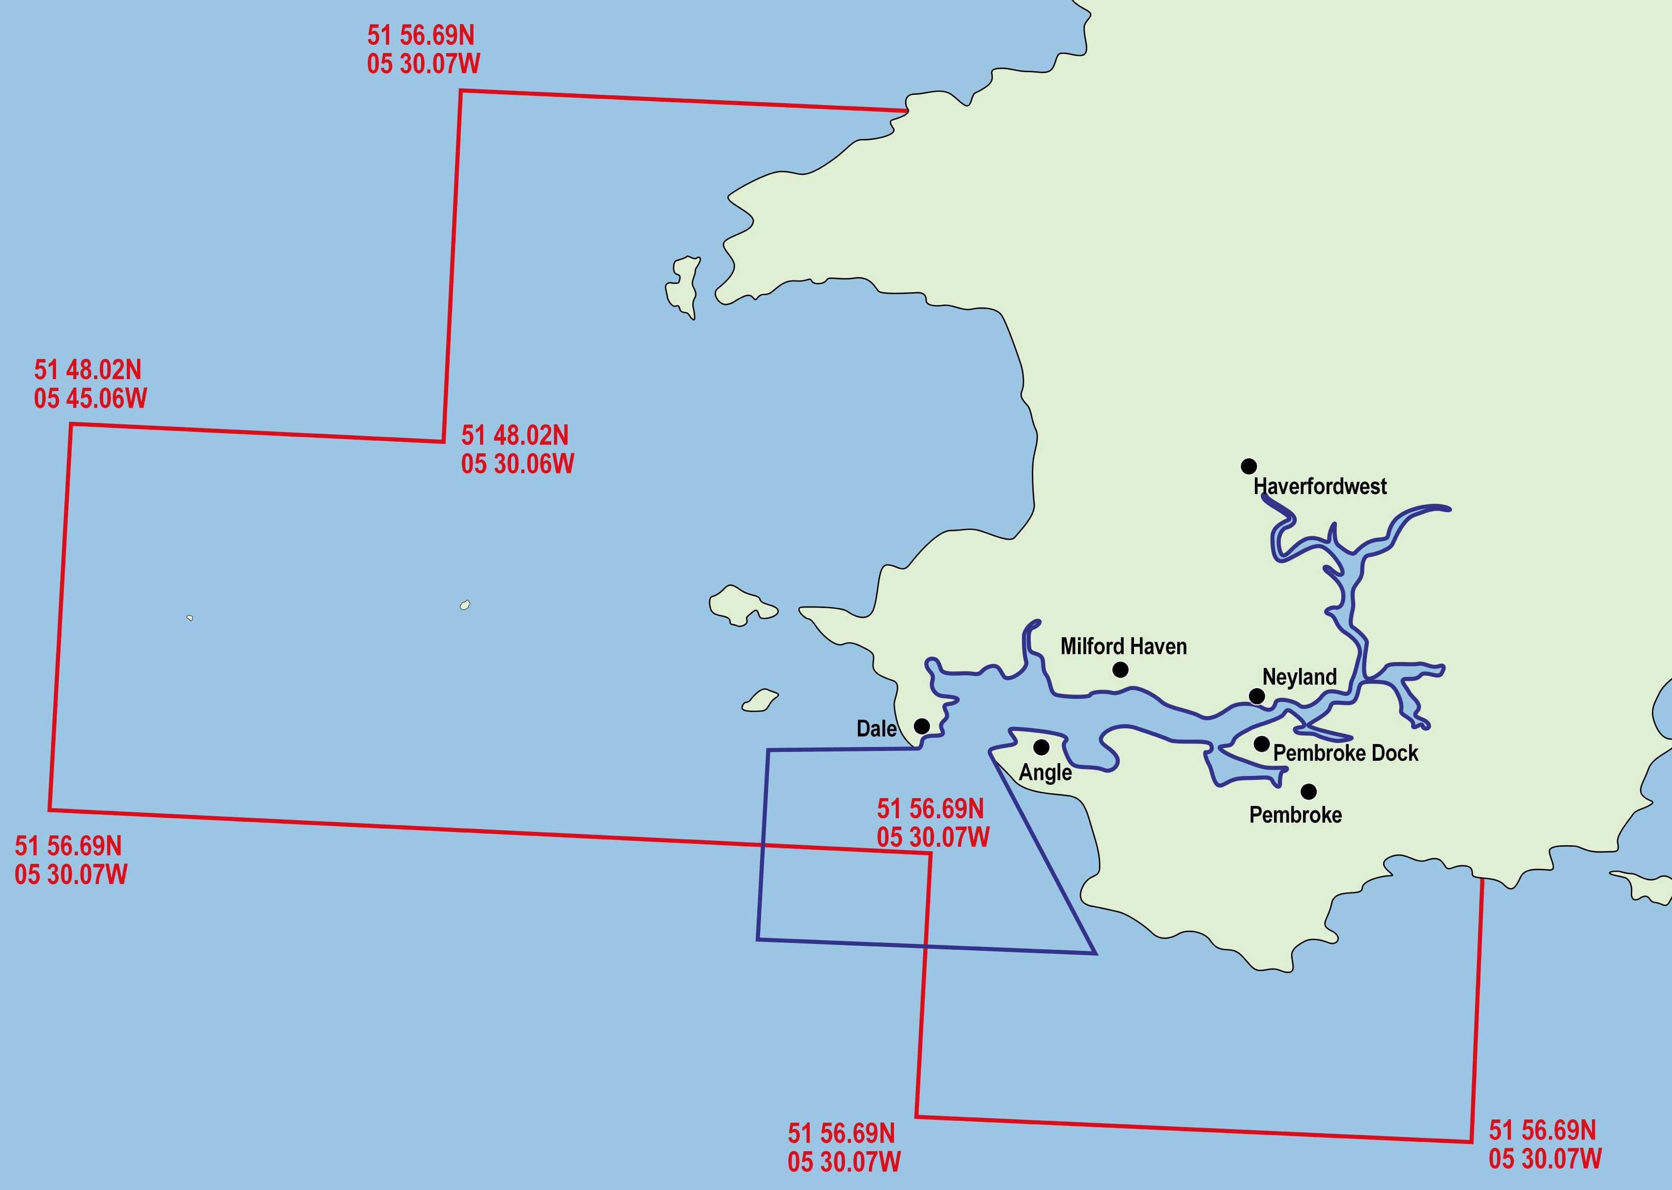

Figure 2 Map showing the Boundary of the Pembrokeshire Marine SAC (in red) and the boundary of the Port of Milford Haven Port Limits (in blue)

The Pembrokeshire Marine Code (PMC)
The PMC is a code of conduct for all boats / watercraft operating in Pembrokeshire which gives advice on how to minimise disturbance to marine wildlife during activities. Some of the cliffs, gullies, beaches and passages around Pembrokeshire’s coastline and offshore islands have agreed seasonal access restrictions in place to help ensure that seals, cetaceans and seabirds are not disturbed.
Please visit www.pembrokeshiremarinecode.org.uk or contact the Marine Code officer on the details below for close up maps of North and South Pembrokeshire’s agreed seasonal access restrictions and codes of conduct, and plan events accordingly.

Planning an event with Port of Milford haven Port Limits.

Organisers of events with port limits are required to obtain the permission of the Harbourmaster. Byelaw 55 ‘Conduct of regattas, etc.’ states:-

The organiser of any boat race, regatta or any other occasion when a number of vessels is expected to assemble on the waters of the Haven shall give not less than seven days notice thereof to the Harbourmaster. All races and similar events shall be conducted on courses and at times previously approved by the Harbourmaster.

Organisers planning to use the facilities of the port are expected to have plans in place to take appropriate measures to ensure that events are safe and well managed. These plans will form part of the Method Statement and Risk Assessments submitted to and reviewed by the Port of Milford Haven prior to the event. Organisers are also expected to plan to minimise any potential impacts / disturbance to the marine environments and wildlife of Haven and all other areas of the Pembrokeshire Marine SAC in accordance with wildlife legislation and local codes of conduct.

When organising your event please ensure that you complete the event proforma included with this document and submit it with any supporting documentation to the Harbourmaster Team.

Contacts details for the Harbourmaster Team, key conservation organisations and coastal managers to get advice from / inform at an early stage about any event plans which have the potential to impact on the habitats / species / marine environments of Pembrokeshire are listed below.

List of contacts for event planners:
It is highly recommended that event organisers contact the Harbourmaster Team, coastal managers and nature conservationists to seek advice at an early stage of the planning process for events.

Organisation | Contact Name | Email | Telephone
Natural Resources Wales | Emma Lowe or Adam Cooper | Emma.lowe@cyfoethnaturiolcymru.gov.uk : adam.cooper@cyfoethnaturiolcymru.gov.uk | 03000 653000
SeaTrust | Cliff Benson | info@seatrust.org.uk | 01348 688588
SAC Officer | Sue Burton | sue.burton@mhpa.co.uk | 01646 696100
Pembrokeshire Coast National Park Authority | Libby Taylor | Libbyt@pembrokeshirecoast.org.uk | 01646 624800
Pembrokeshire County Council | Gary Nicholas | gary.nicholas@pembrokeshire.gov.uk | 01437 764551
Port of Milford Haven | Brian Macfarlane | recreation@mhpa.co.uk | 01646 696100
Pembrokeshire Marine Code | Alec Denny | Alec.denny@pembrokeshirecoastalforum.org.uk | 07989 218489

Here are the email addresses of contacts formatted to copy and paste directly into an email address bar:

info@seatrust.org.uk; sue.burton@mhpa.co.uk; Libbyt@pembrokeshirecoast.org.uk; mhparecreation@mhpa.co.uk; alec.denny@pembrokeshirecoastalforum.org.uk ; gary.nicholas@pembrokeshire.gov.uk

Further Information: Why is Pembrokeshire so Special?
Following is a brief summary of why Pembrokeshire is so special with brief notes on cetaceans and sea birds.
Cetaceans
As the map below indicates there is a wide variety of cetacean species in the Irish Sea area to the West of Pembrokeshire. Eighteen species of cetacean have been recorded in Welsh waters since 1990. Five species (harbour porpoise, bottlenose dolphin, short-beaked common dolphin, Risso’s dolphin and minke whale) are relatively common.

Figure 3 Interpolated map of the number of cetacean species recorded per cell
1990 – 2007

© CCGC/CCW 2009 Baines, M.E. and Evans, P.G.H. (2009). Atlas of the Marine Mammals of Wales. CCW Monitoring Report No. 68.

As can be seen from the map below, cetacean sightings to the west of Pembrokeshire are widespread.

Figure 4 – Long term quarterly mean sightings rates of common dolphin.
1990 – 2007

© CCGC/CCW 2009 Baines, M.E. and Evans, P.G.H. (2009). Atlas of the Marine Mammals of Wales. CCW Monitoring Report No. 68.

Seabirds:
Pembrokeshire is of international importance for colonies of seabirds such as Manx Shearwaters, Auks and Gannets. The areas shaded in blue below have been designated as special protection areas for seabirds. Details on the individual sites can be found here http://www.jncc.gov.uk/page-1400
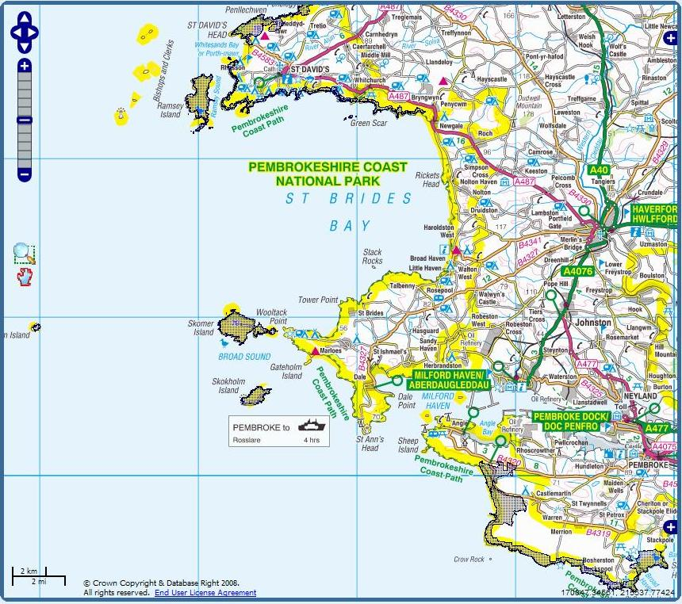
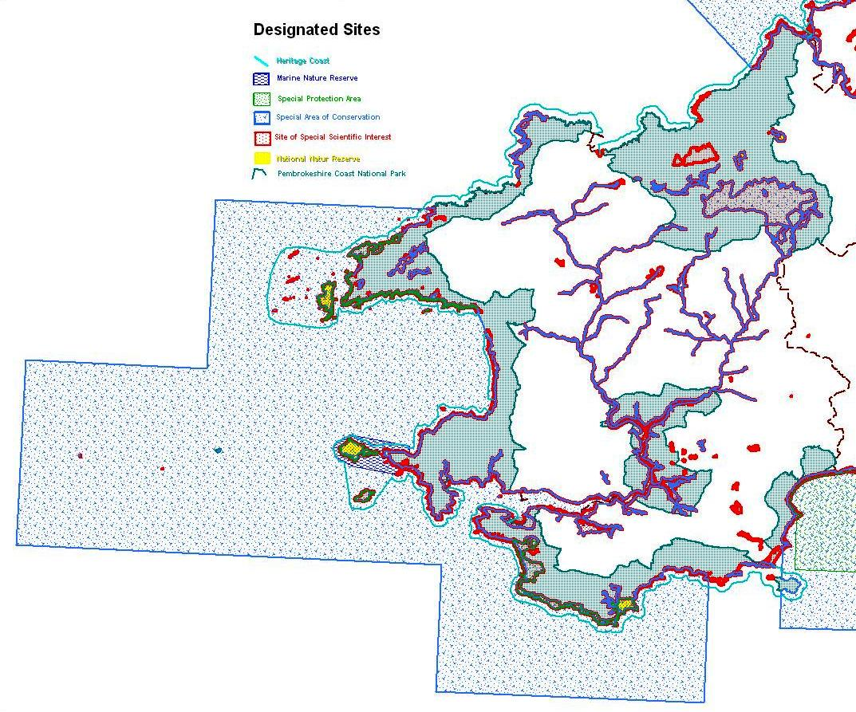
Heritage Coast
Marine Nature Reserve
Special Protection Area

Special Area of Conservation
Site of Special Scientific Interest
National Nature Reserve
Pembrokeshire Coast National Park
Here is a summary of areas in Pembrokeshire designated for nature conservation.

